**PHASE 3**

**Primary Keys are underlined with black solid lines**

**Partial Keys are underlined with black dashed lines**

**Foreign Keys are in blue**

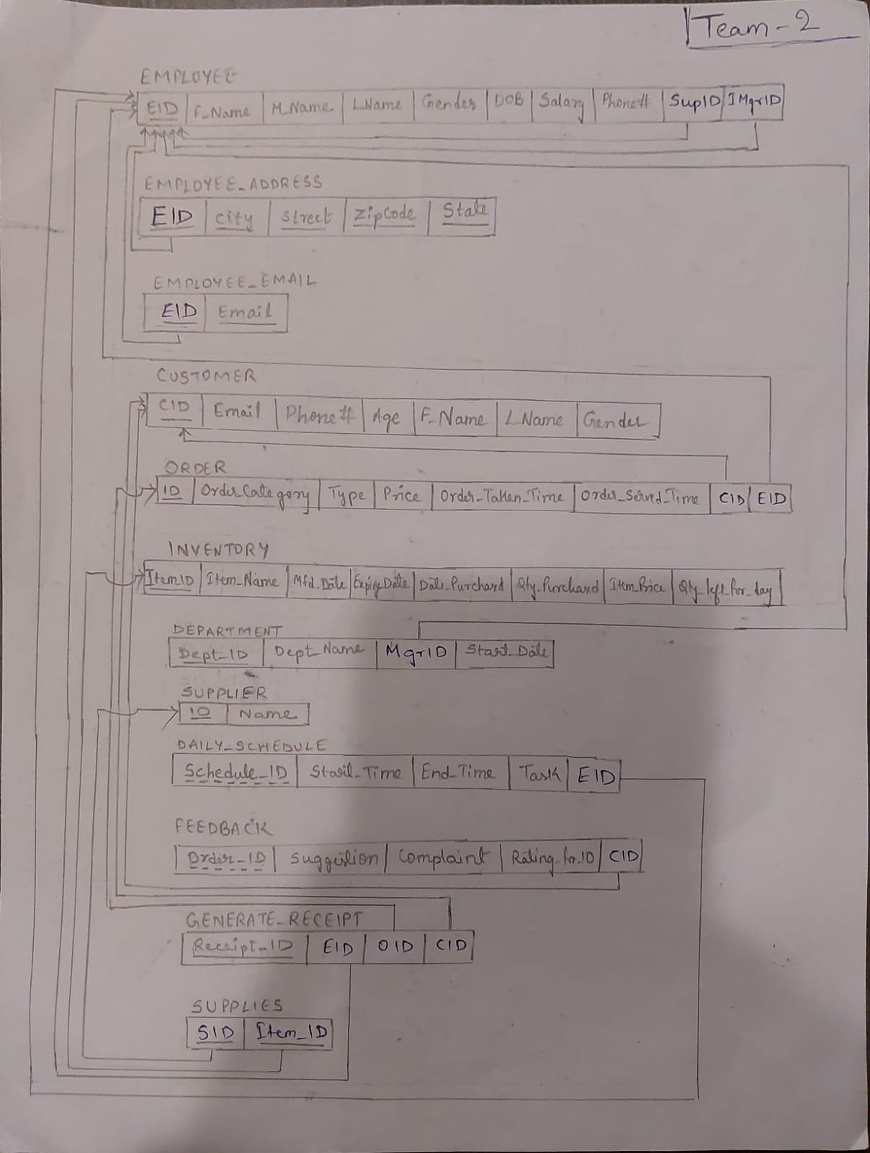

**Here SupID is the Supervisor ID , IMgrID is the Inventory Manager ID and MgrID is Manager ID**

**In Supplies Relation SID is the Supplier ID**

**Candidate Keys**

1. **EMPLOYEE**

* EID
* { EID, SupID, IMgrID }

1. **EMPLOYEE_ADDRESS**

* { EID, City, Street, ZipCode, State}

1. **EMPLOYEE_EMAIL**

* { EID, Email }

1. **CUSTOMER**

* CID

1. **ORDER**

* ID
* { ID, CID, EID }

1. **INVENTORY**

* Item_ID

1. **DEPARTMENT**

* Dept_ID
* { Dept_ID, MgrID }

1. **SUPPLIER**

* ID

1. **DAILY_SCHEDULE**

* { Schedule_ID, EID}

1. **FEEDBACK**

* { Order_ID, CID }

1. **GENERATE_RECEIPT**

* Receipt_ID

1. **SUPPLIES**

* { SID, Item_ID}

**Functional Dependencies**

1. **EMPLOYEE**

* EID -> {F_Name, M_Name, L_Name, Gender, DOB, Salary, Phone#, Sup_ID, IMgrID}
* {EID, Sup_ID, IMgrID} -> {F_Name, M_Name, L_Name, Gender, DOB, Salary, Phone#}

1. **EMPLOYEE_ADDRESS**

* {EID, City, Street, ZipCode, State} -> EID

1. **EMPLOYEE_EMAIL**

* {EID, Email} -> EID

1. **CUSTOMER**

* CID -> {Email, Phone#, Age, F_Name, L_Name, Gender}

1. **ORDER**

* ID -> {Order_Category, Type, Price, Order_Taken_Time, Order_Served_Time, CID, EID}
* {ID, CID, EID} -> {Order_Category, Type, Price, Order_Taken_Time, Order_Served_Time}

1. **INVENTORY**

* Item_ID -> {Item_Name, Mfd_Date, Expiry_Date, Date_Purchased, Qty_Purchased, Item_Price, Qty_left_for_day,}

1. **DEPARTMENT**

* Dept_ID -> {Dept_Name, MgrID, Start_Date}
* {Dept_ID, MgrId} -> {Dept_Name, Start_Date}

1. **SUPPLIER**

* ID -> Name

1. **DAILY_SCHEDULE**

* {EID, Schedule_ID} -> {Start_Time, End_Time, Task}

1. **FEEDBACK**

* {CID, Order_ID} -> {Suggestion, Complaint, Rating_for_10}

1. **GENERATE_RECEIPT**

* Receipt_ID -> {EID, OID, CID}

1. **SUPPLIES**

* {SID,Item_ID} -> SID
* {SID, Item_ID} -> Item_ID

**Team Information:**

**Team ID: 2**

|  |  |
| --- | --- |
| **Name** | **ID** |
| Vishnu Vardhan Reddy Chitipiralla | 1002073418 |
| Sureddy Shivani Reddy | 1002072975 |
| Srikeerthi Srinivasan | 1002059216 |
| Nitya Vodela | 1002070544 |